1.Launch one EC2 using Amazon Linux 2 image and add a script in user data to install Apache

Launch EC2 with Apache Installed Automatically
1. Go to AWS Console
- Open AWS Console
- Go to EC2 Dashboard
- Click Instances → Launch instance

2. Choose Name
- Name: My-Apache-Server

3. Choose AMI
- Under Application and OS Images (Amazon Machine Image)
Select: Amazon Linux 2 AMI (HVM), SSD Volume Type
4. Choose Instance Type
- Select: t2.micro (Free tier eligible)
5. Key Pair
- Choose an existing key pair OR create a new one.
6. Network Settings
Click Edit and allow HTTP:
- VPC: default (or your VPC)
- Subnet: Any
- Auto-assign public IP: Enable
- Firewall (Security Group):
  - Allow SSH (port 22) — for login
  - Allow HTTP (port 80) — to access Apache website

7. Add User Data Script (VERY IMPORTANT)
Scroll to Advanced Details → User Data
Paste the below script:
#!/bin/bash
yum update -y
yum install httpd -y
systemctl start httpd
systemctl enable httpd
echo "<h1>Welcome to Syed's Apache Server on AWS EC2!</h1>" > /var/www/html/index.html
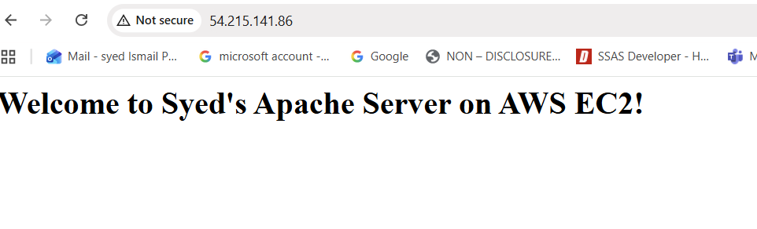

2.Launch one Windows server and install Tomcat on Windows.

Go to EC2 Dashboard
AWS Console → EC2 → Instances → Launch Instance

2. Name
Example:
Ubuntu-Nginx-Server

3. Choose AMI (Image)
Under Application and OS Images (AMI):
👉 Select: Ubuntu Server 22.04 LTS (HVM), SSD Volume Type

4. Choose Instance Type
Select: t2.micro (Free tier eligible)

5. Key Pair
Choose or create a key pair.

6. Network Settings
Click Edit:
- Auto-assign public IP: Enable
- Security Group:
  - Allow SSH (22) → to access server
  - Allow HTTP (80) → to access Nginx
  - Allow All Traffice

7. Add User Data Script
Scroll to:
Advanced details → User Data
Paste this script:
#!/bin/bash
apt update -y
apt install nginx -y
systemctl start nginx
systemctl enable nginx
echo "<h1>Welcome to Syed's Nginx Server on Ubuntu!</h1>" > /var/www/html/index.html

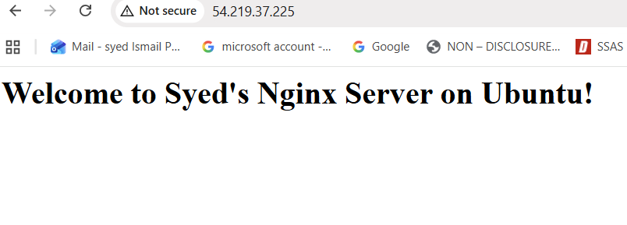

3.Launch one Windows server and install Tomcat on Windows.

3. Launch one Windows server and install Tomcat on Windows.
Steps You Performed (Short & Clear)
1️⃣ Launched a Windows EC2 instance
• Selected Windows Server
• Instance type: t3.medium
• Used existing key pair: Testing.pem
• Added Security Group rules: RDP (3389) and Tomcat (8080)
________________________________________
2️⃣ Retrieved Windows Administrator password
• Went to Actions → Security → Get Windows Password
• Uploaded Testing.pem
• Decrypted and copied the password
________________________________________
3️⃣ Connected to EC2 using RDP
• Downloaded the RDP file
• Logged in using:
o Username: Administrator
o Decrypted password
________________________________________
4️⃣ Installed Java
• Downloaded Temurin JDK 17 MSI
• Installed normally (Next → Next)
________________________________________
5️⃣ Installed Apache Tomcat
• Downloaded Tomcat Windows Service Installer (.exe)
• Installed → Tomcat service started automatically
________________________________________
6️⃣ Allowed port 8080 in Windows Firewall
• Added inbound rule for TCP 8080
________________________________________
7️⃣ Verified Tomcat
• Opened browser:
http://<EC2-public-ip>:8080
• Saw the Apache Tomcat welcome page

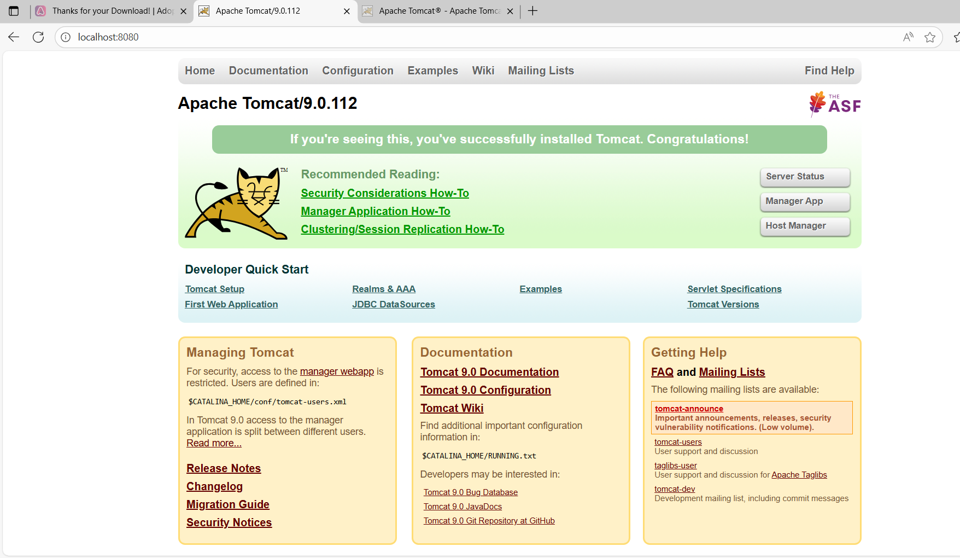
4.Take a snapshot of the instance created in Task 1.

✅ Step-1: Go to EC2 Console
Open AWS → Search EC2 → Open it.

✅ Step-2: Go to Instances
From the left side menu → Click Instances.

✅ Step-3: Select Your Instance
Click the checkbox of the instance you created in Task 1.

✅ Step-4: Find Your Root Volume
Scroll down to the Storage section.
You will see something like:
- Root volume ID → vol-0abcd12345...
Click on that Volume ID.

✅ Step-5: Create Snapshot
Now you are inside the EBS Volume page.
Click on:
Actions → Create snapshot

✅ Step-6: Enter Details
A popup will appear.
Fill:
- Name: task1-snapshot
- Description: snapshot for task 1 server
Then click:
Create snapshot

✅ Step-7: Check the Snapshot
Left side menu → Snapshots
You will see the snapshot with status pending → completed.

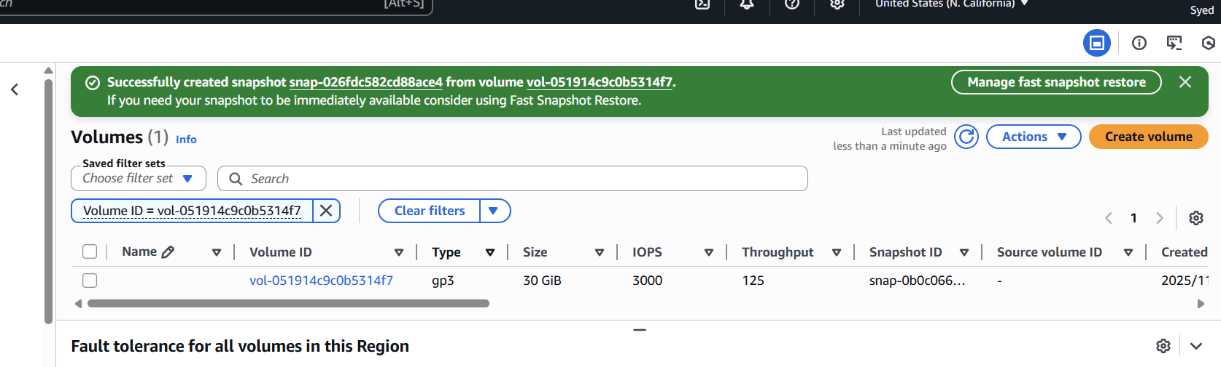

5.Passwrodless authentication
steps:
ssh-keygen
It will appear the key copy
Cat /c/user/Ismail/.ssh/id/sa.pub
It will the key copy
Login the instances
cd.ssh/
ls
vi authorized_keys
paste the copied key here
exit
ssh ec2-user 54.177.98.61

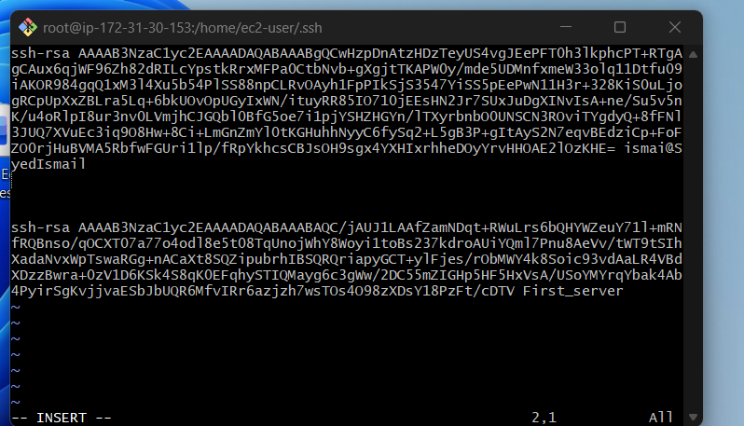

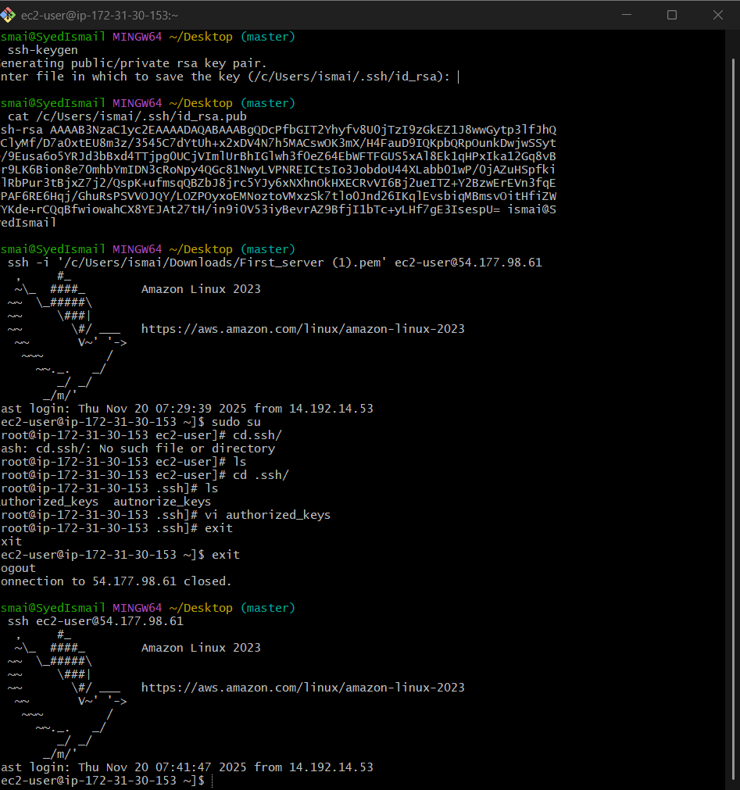

Launch any EC2 using the spot purchasing option.

Go to the EC2 console, click "Launch Instances,"
and in the "Advanced Details" section,
select the "Request Spot Instances" checkbox

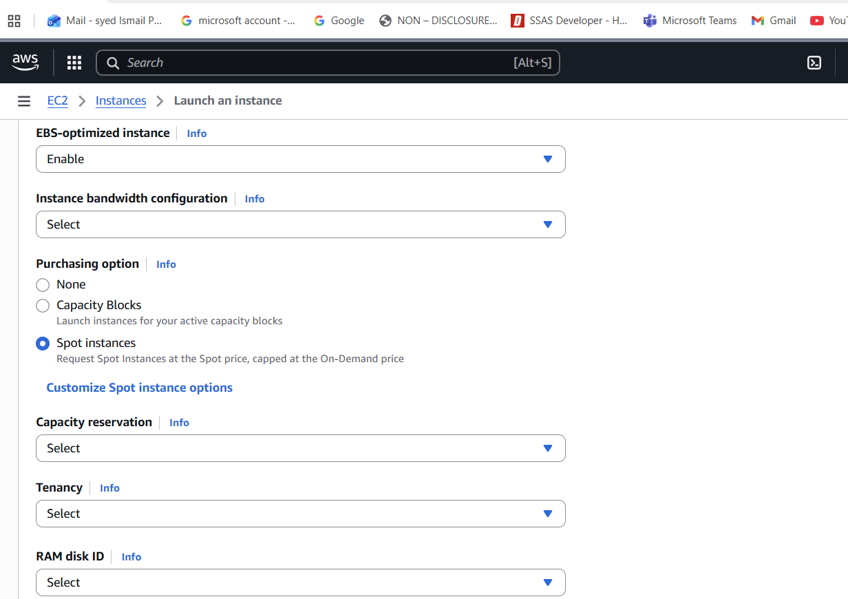

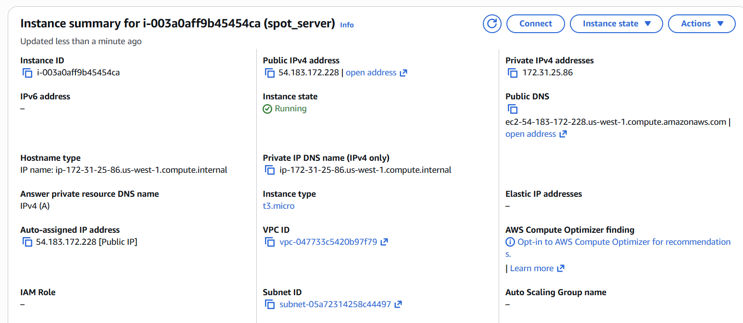

Enable termination policy on the EC2 created in Task 2.

